# **IMS USER MANUAL**

**GET STARTED**

Open **UETIMS** app.

**Registration:**

Make sure you have active internet connection.

* Enter valid email, and other details.
* Click Register Button.

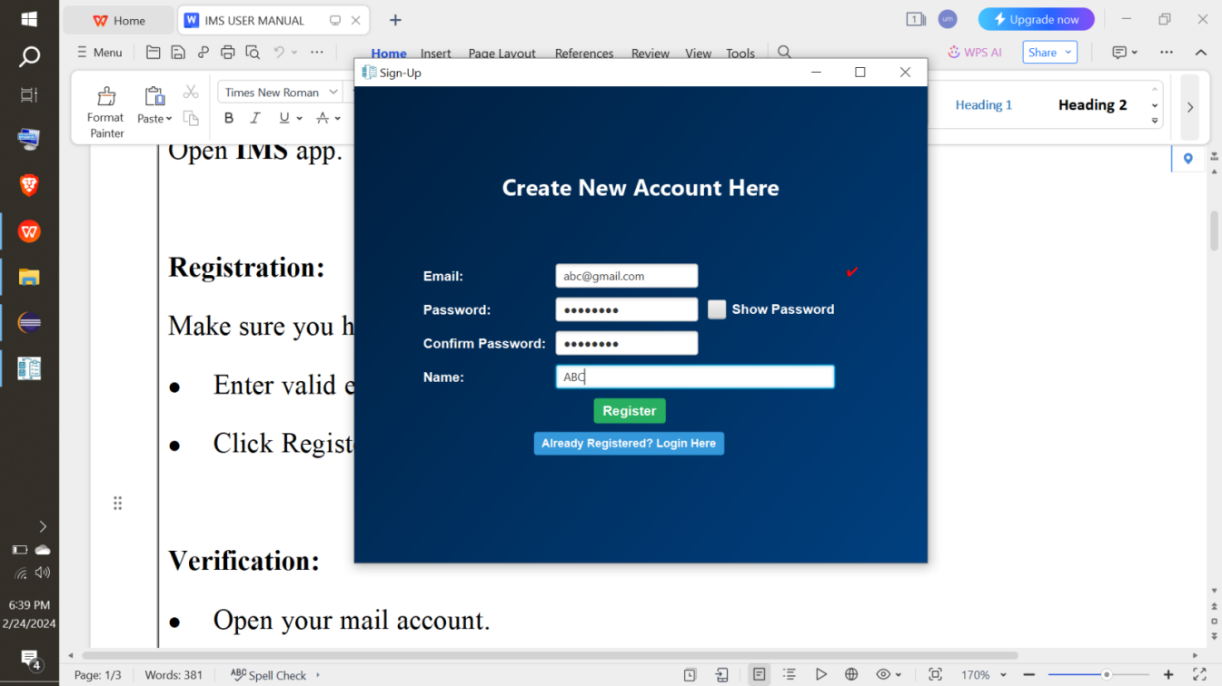

**Note:** Only one admin is allowed to register an account at a time.

**Note:** Internet connection is necessary to register an account.

**Verification:**

* Open your mail account.
* Copy verification code.
* Paste that code in verification window.
* Click Verify Button.

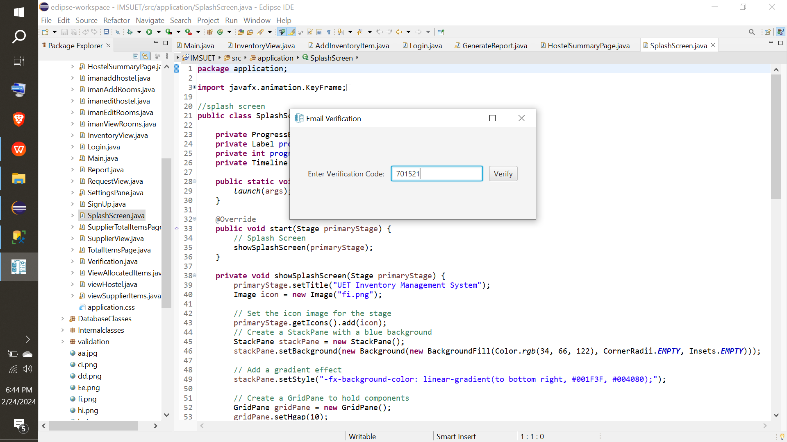

**Login-In:**

* Enter valid credentials.
* Click Login Button.

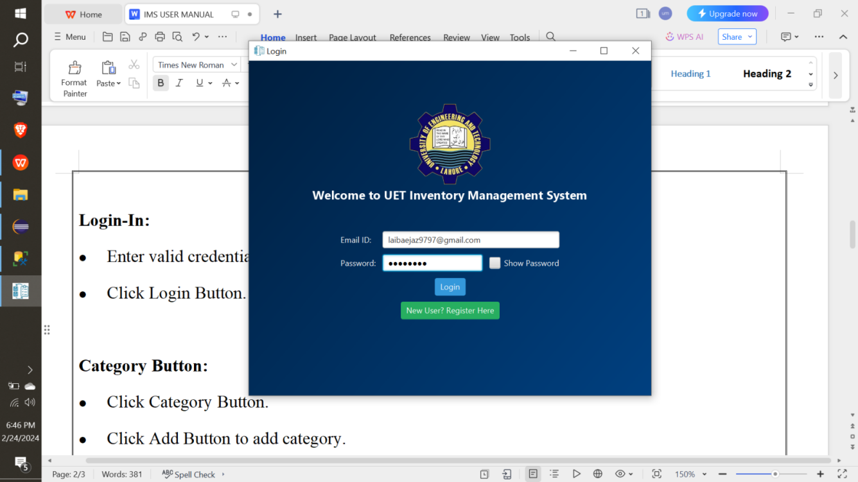

**Dashboard:**

* Pie-chart presents category of items present in inventory based on inventory count.
* Bar-chart presents allocated(to rooms) and un-allocated(present in inventory) count of categories based on items.
* Click User Account Button(B1) to see user profile.
* Click Category Button(B2) to view categories.
* Click Inventory Button(B3) to view inventory items.
* Click Suppliers Button(B4) to view suppliers.
* Click Hostel Button(B5) to view hostels.
* Click Requisition Button(B6) to view student requisitions.
* Click Generate Report(B7) to view supplier summary.
* Click Logout Button(B8) to logout from app.

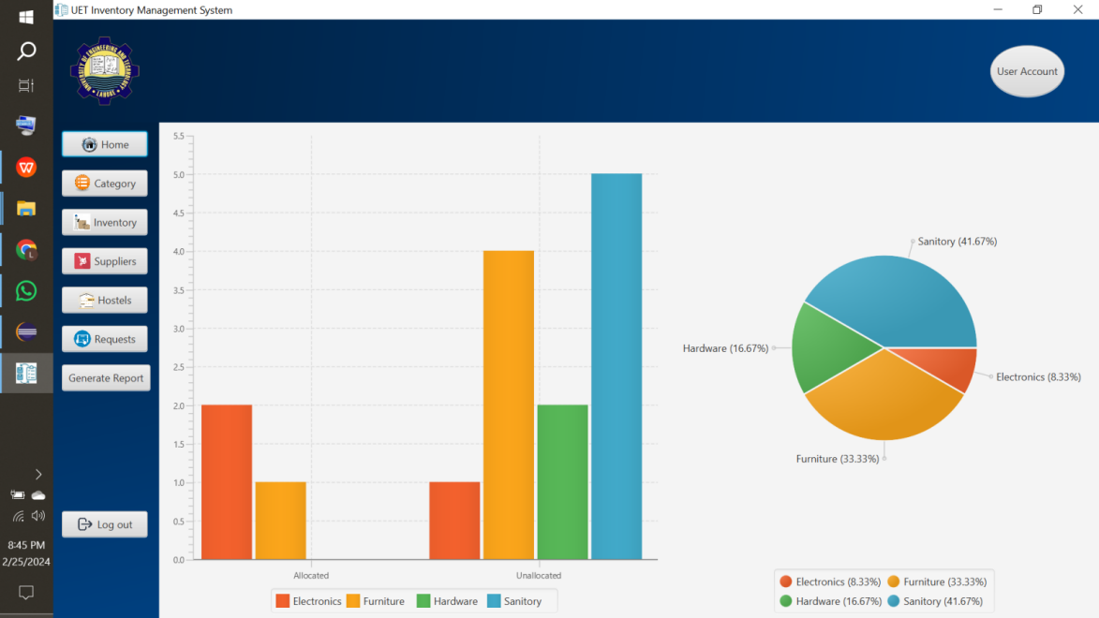

B2B3B4B5B6B7

B8

B11

**User Account:**

* Click Edit Profile Button(B1) to edit username.
* On clicking edit profile button(B1), a placeholder for editing username would be displayed, edit the username and click save changes button(B3).
* Click Delete Account Button(B2) to delete account permanently by entering correct current password and clicking Confirm Deletion Button(B4).

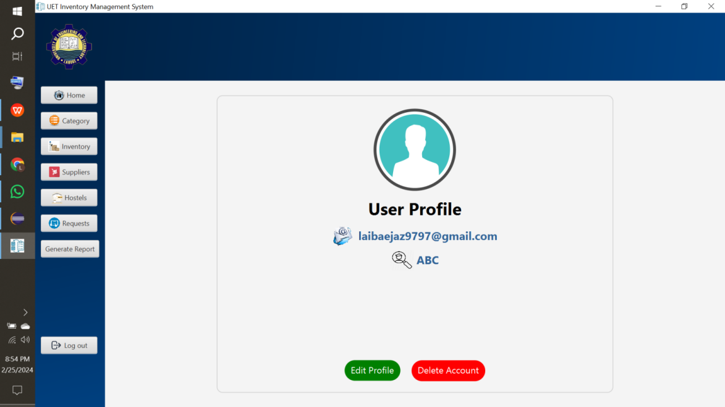

B2

B11

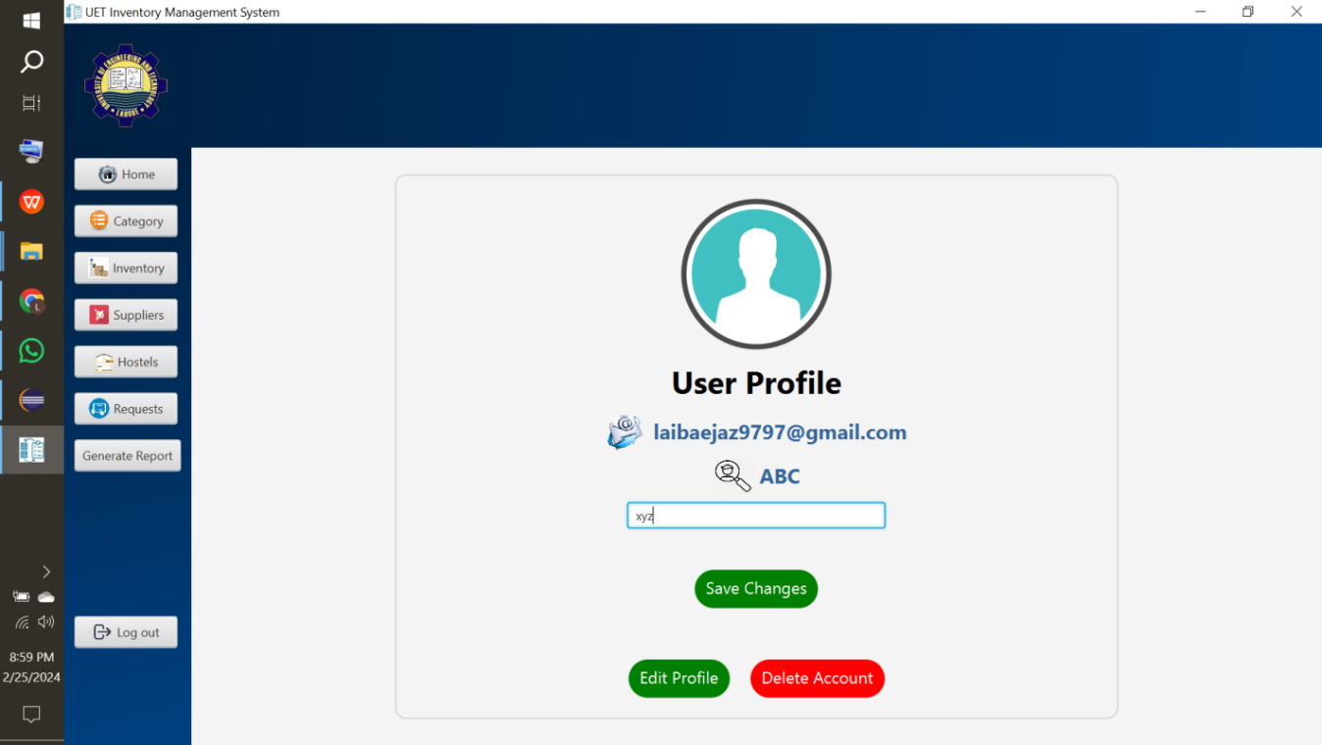 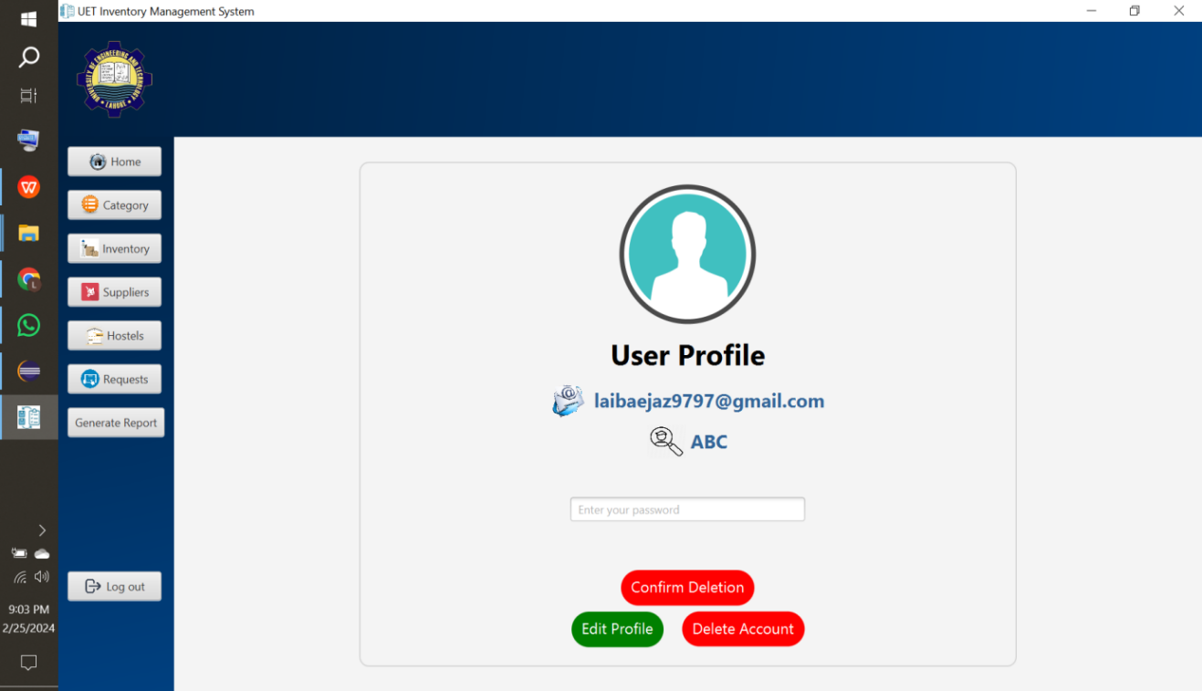

B41

B31

**Warning:** Deleting account will delete your account but keeping in view that this hostel data belongs to hostel management not specific person, so by signing-up with new email, you can get access to app with same data.

**Category Button:**

* Click Category Button (B1).
* Click Add Button(B2) to add category.
* On clicking Add Button, a new page would be opened. Fill all data fields and click add category button (B3).
* Select a category and click Edit Button(B4) that new page would be opened, edit desired field and click edit category button(B5) to edit it.
* Select a category and click Delete Button(B6) to delete it.
* Search category by selecting Category Name from drop-down menu(D1) and then type desired data in search-placeholder(D2).

D2

D11

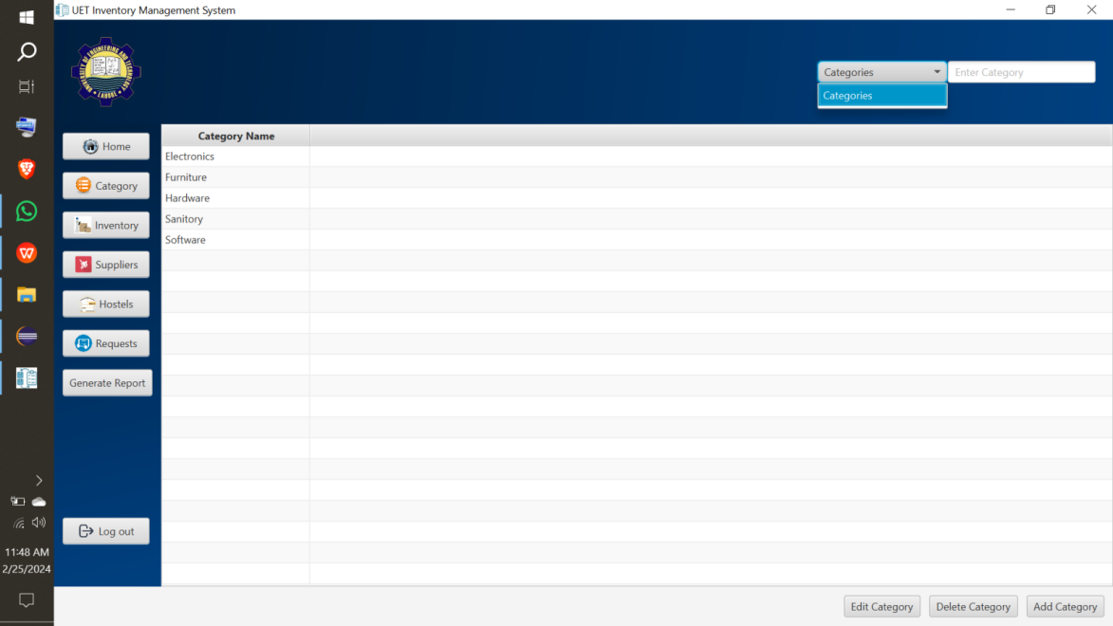

B21

B61

B41

B11

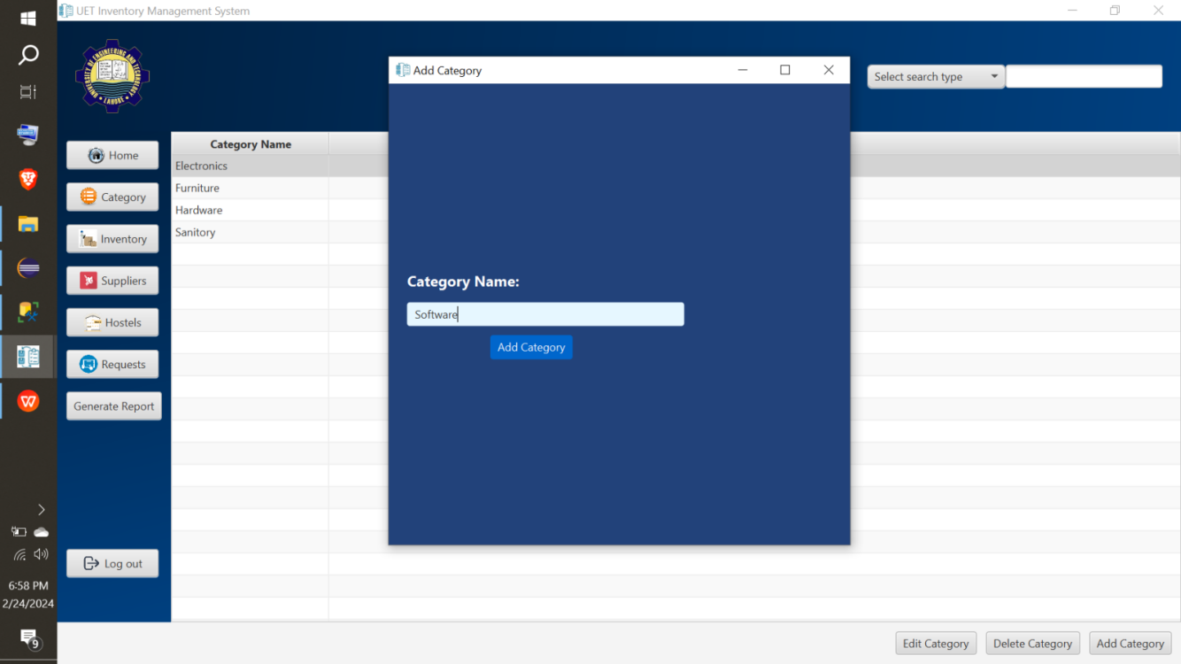 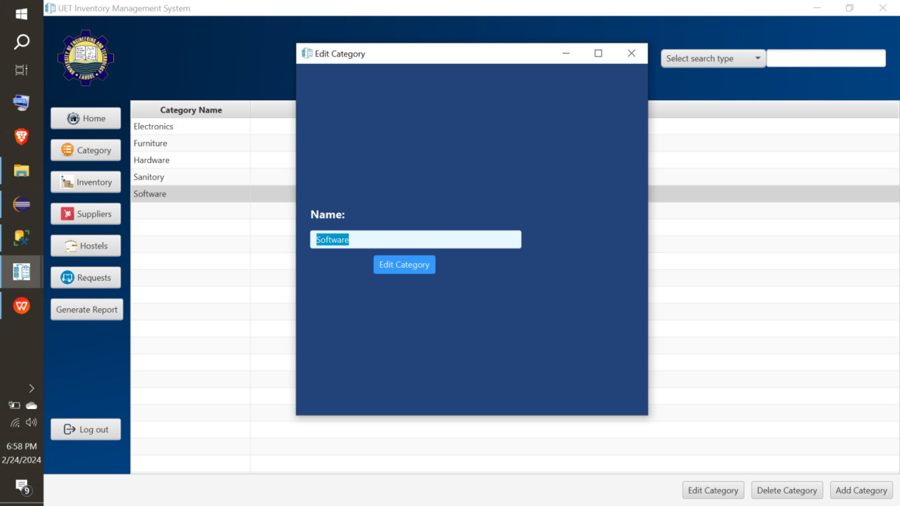

B51

B31

**Warning:** You cannot add more than one category with same name.

**Hostel Button:**

* Click Hostel Button(B1).
* Click Add Button(B2) to add hostel.
* On clicking Add Button, a new page would be opened. Fill all data fields and click add hostel button (B3).
* Search hostel by selecting Hostel Name, or No. Of Floors from drop-down menu(D1) and then type desired data in search-placeholder(D2).
* Select a hostel and click Edit Button(B4) that new page would be opened, edit desired field and click edit hostel button(B5) to edit it.
* Select a hostel and click Delete Button(B6) to delete it.
* Click Hostel Summary Button(B7) to view Hostel Summary of Hostels having no. Of items in each hostel.
* On clicking Hostel Summary Button(B7) , a new page would be opened. You can view and download hostel summary by click download icon(B8). Search by selecting Hostel Name, Item Name, or Item Category from drop-down menu(D3) and then type desired data in search-placeholder(D4).
* Select a hostel to view rooms of respective hostel.
* Click View Room Button(B9).

D21

D11

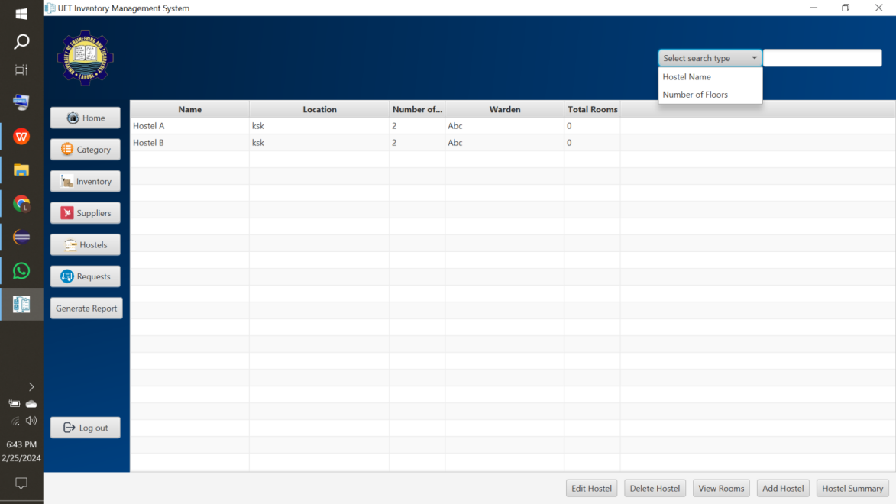

B4

B9

B7

B2

B6

B11

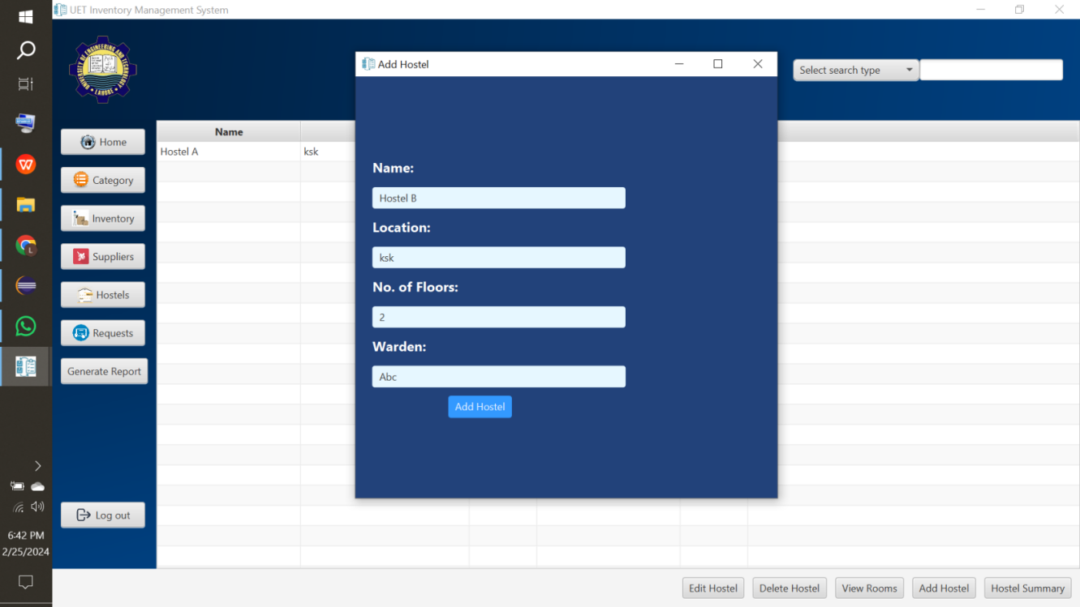 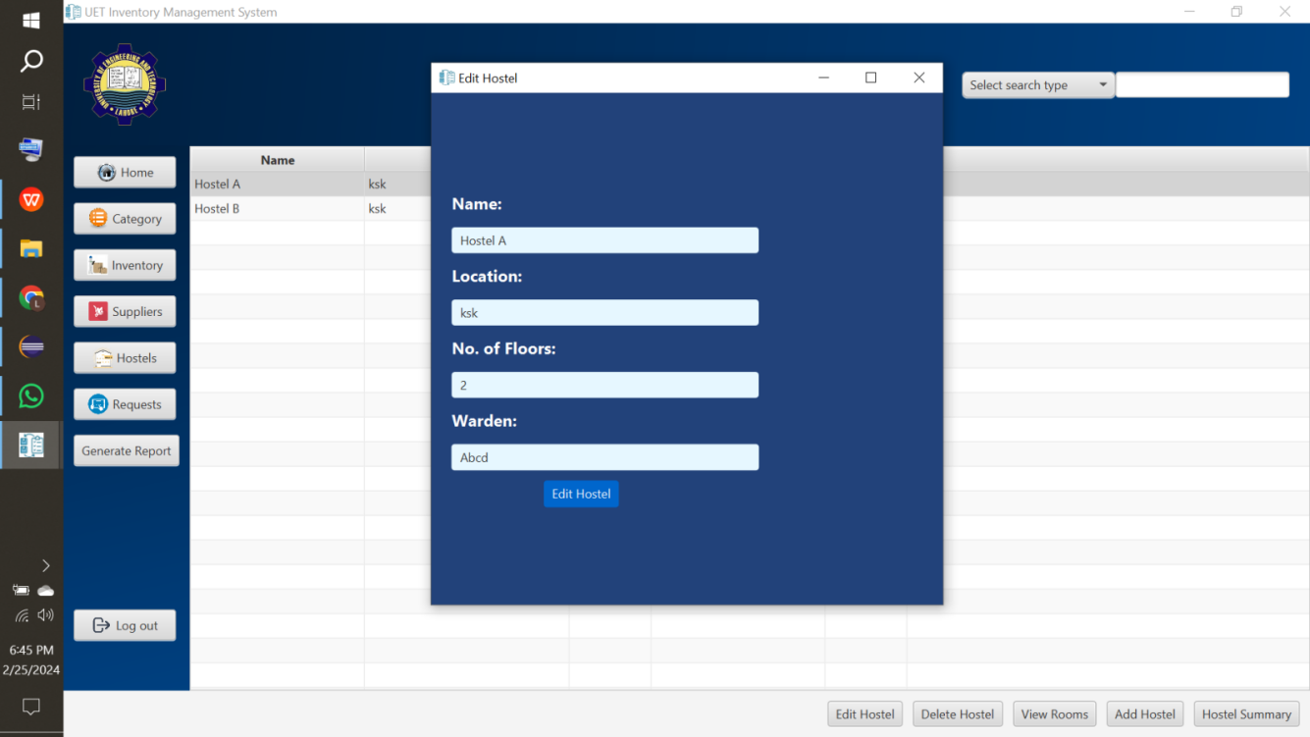

B5

B3

D3

D4

B8

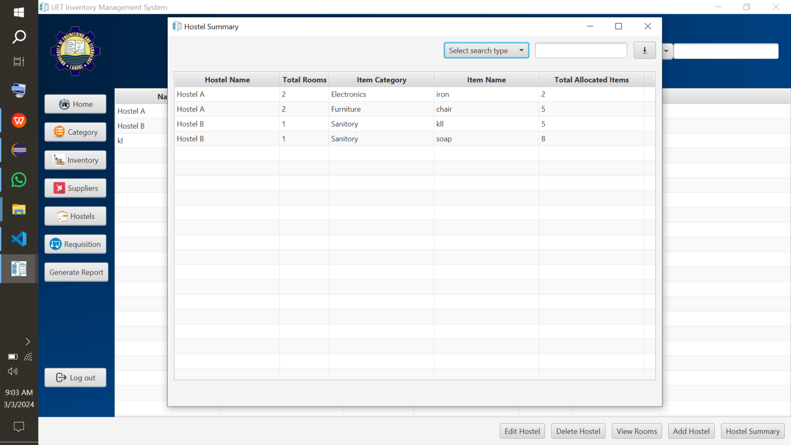

**Warning:** Deleting hostel will delete respective rooms and their allocated items as well.

**Warning:** You cannot add more than one hostel with same name.

**View Room Button:**

* Select a hostel to view rooms of respective hostel from hostel page( the screenshot given in **View Hostel Button**) and click **View Room Button**(B1).
* Click Add Room(B2) to add room.
* On clicking Add Button, a new page would be opened. Fill all data fields and click add room(B4).
* Search room by selecting Room No., Room Category, or Floor Number from drop-down menu (D1) and then type desired data in search-placeholder(D2).
* Select a room and click Edit Button(B5) that new page would be opened, edit desired field and click edit room button(B6) to edit it.
* Select a room and click Delete Button(B7) to delete it.
* Select a room and click View Item Button(B8)to view allocated items to respective room.
* Click View Hostel(B9) to go back to hostel page.

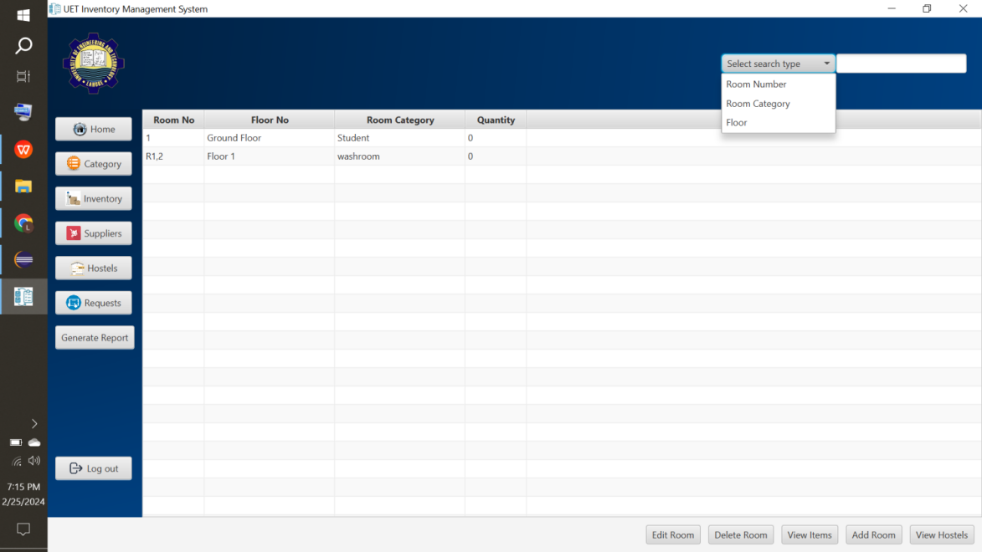

B5

B7

B8

B2

B9

D1

D2

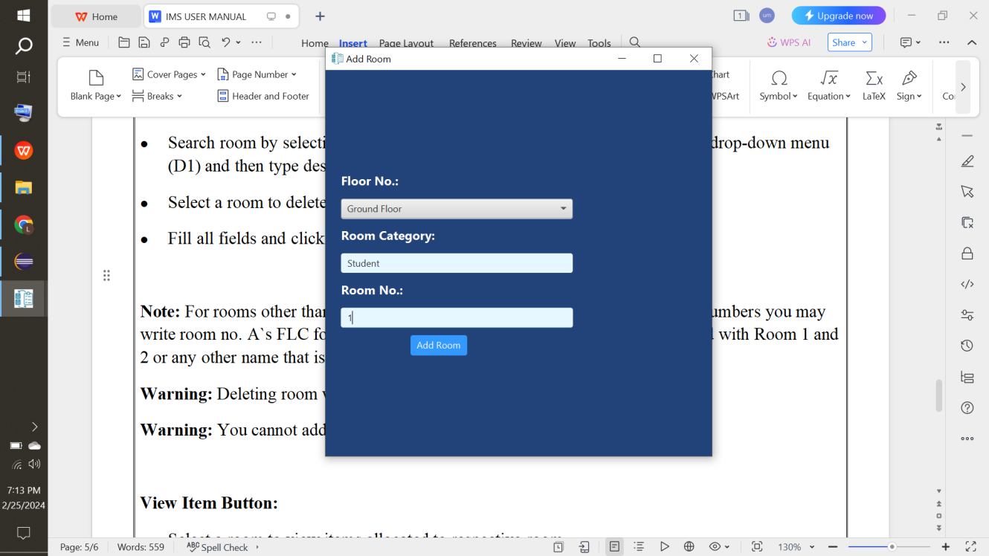 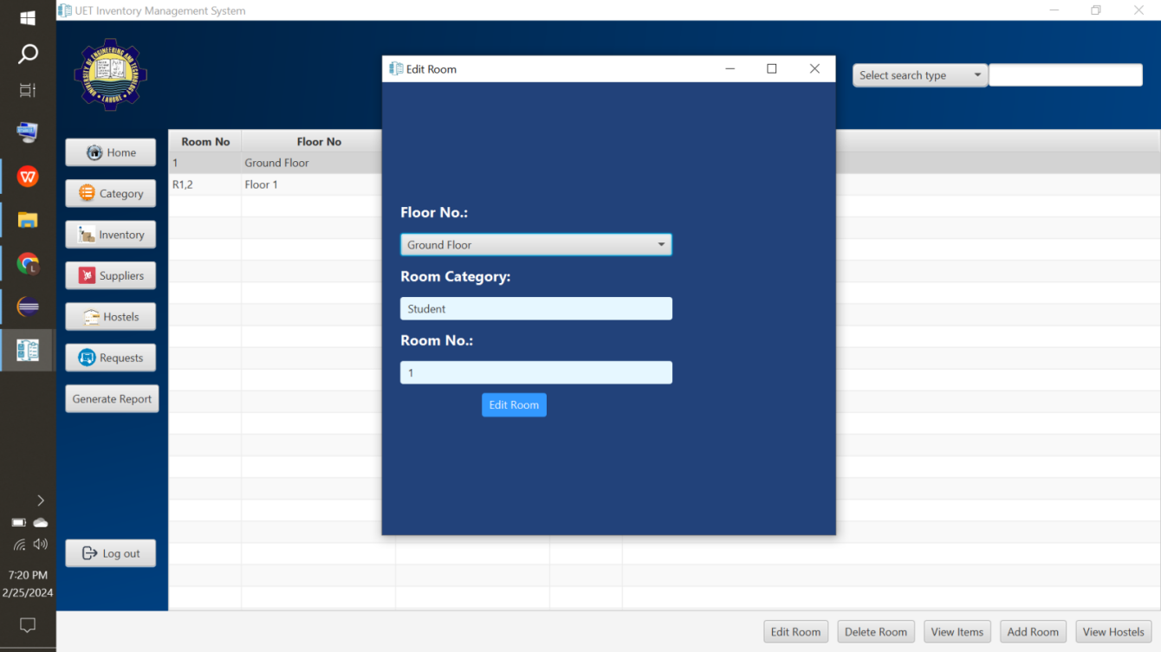

B6

B4

**Note:** For rooms other than student rooms(1, 2 is allowed) that don’t have room numbers you may write room no. as FLC for first floor left corridor, R1,2W for washroom attached with Room 1 and 2 or any other name that is convenient.

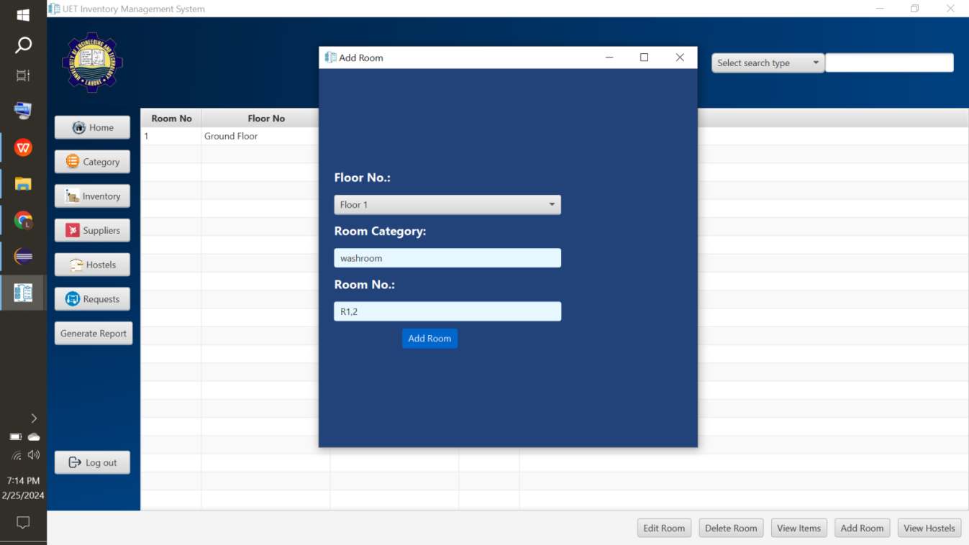

**Warning:** Deleting room will delete respective allocated items as well.

**Warning:** You cannot add more than one room with same room no.

**View Item Button(Allocated Item):**

* Select a hostel to view rooms of respective hostel from hostel page( the screenshot given in **View Hostel Button**) and click **View Room Button**(B1).
* Select a room to view items of respective room from room page( the screenshot given in **View Room Button**) and click **View Item Button**(B1).
* Click Add Item(B3) to add already allocated item to respective room(see first note below).
* On clicking Add Button, a new page would be opened. Fill all data fields and click add item(B4).
* Search item by selecting Allocated Item Name, or Allocated Item Category from drop-down menu(D1) and then type desired data in search-placeholder(D2).
* Select an item and click Edit Button(B5) that new page would be opened, edit desired field and click edit item button(B6) to edit it.
* Select an item and click Delete Button(B7) to delete it.
* In this allocated item page, both already allocated(by add button) having Req No. 0 and through student requisition are displayed with their respected request numbers.
* Click View Room(B8) to go back to room page.

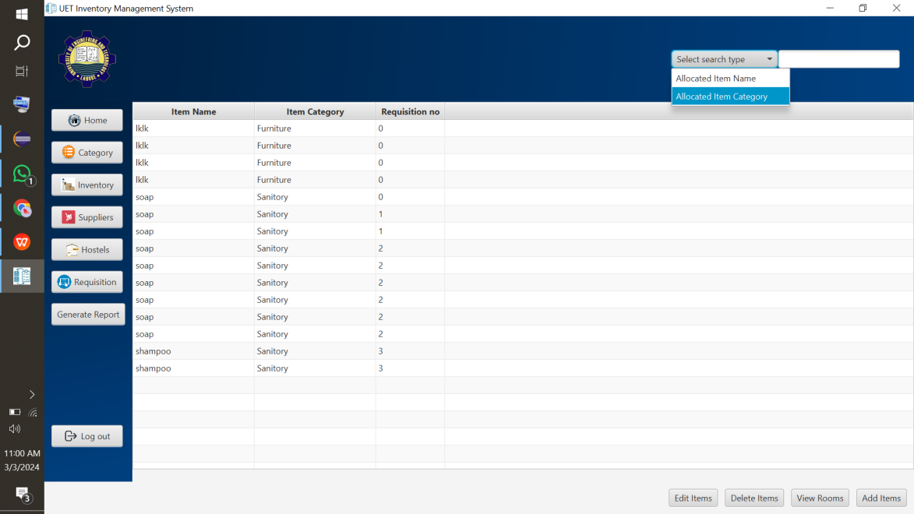

B3

D1

D2

B8

B7

B5

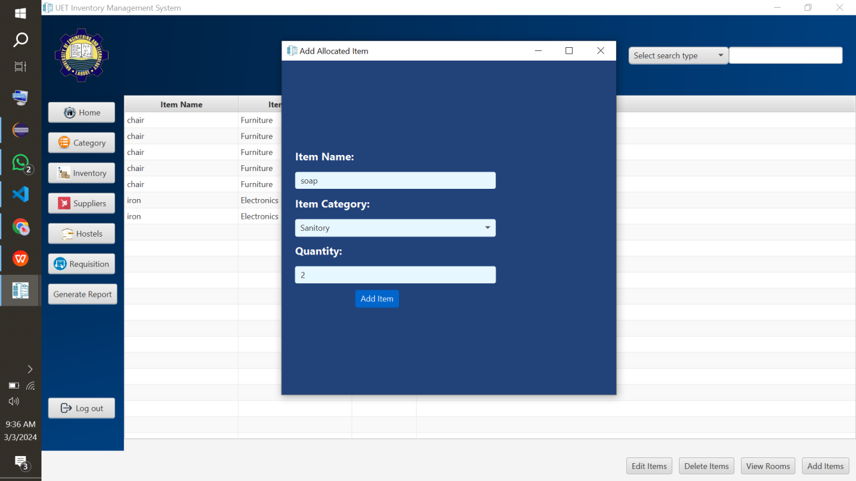 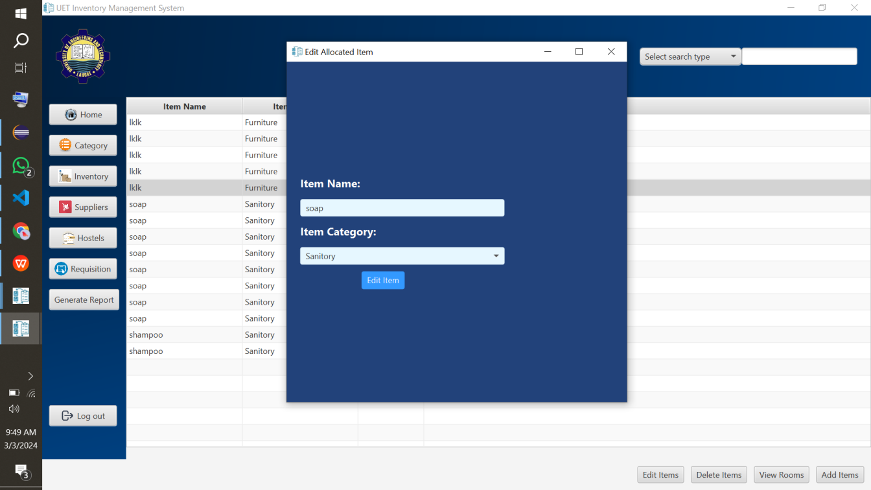

B4

B6

**Note:** When you add item from this page, it is assumed that these items have already been allocated to rooms and you are saving data here, they would not be allocated from inventory. Otherwise to allocate new items to rooms through student requisitions from inventory, we would discuss later in Student Requisition Section.

**Note:**You can select multiple items at a time to edit or delete by **ctrl+click**(mousepad).

**Warning:** Make sure you are adding correct quantity of items otherwise you would have to search for particular item and click **ctrl+a** and delete or edit button to delete or edit all undesired quantity or manually select items you want to delete or edit by selecting them as **ctrl+click**(mousepad).

**Warning:** When selecting multiple enteries and clicking edit button, previous text would not be shown but whatever you would write would be updated for all selected enteries. E.g. you selected an item chair, 2 tables and clicked edit button and written iron as item name so chair and 2 tables would be renamed as iron.

**Warning:** You can only edit or delete those items that you have added manually from this item page but not those allocated through Student Requisition.

**Inventory Button:**

* Click Inventory Button(B1).
* Click Add Item(B2) to add already existing items in inventory(see first note below).
* On clicking Add Button, a new page would be opened. Fill all data fields and click add item button (B3).
* Search item by selecting Item Name, or Item Category from drop-down menu(D1) and then type desired data in search-placeholder(D2).
* Select an item and click Edit Button(B4) that new page would be opened, edit desired field and click edit item button(B5) to edit it.
* Select an item and click Delete Button(B6) to delete it.
* In this inventory page, both manually added(item already in-stock(by user)) and those supplied by supplier(by supplier) are displayed.
* Click Total Item Button(B7) to view total no. of each item in inventory.
* On clicking Total Item Button(B7) , a new page would be opened. You can view and download item summary by click download icon(B8). Search item by selecting Item Name, or Item Category from drop-down menu(D3) and then type desired data in search-placeholder(D4).

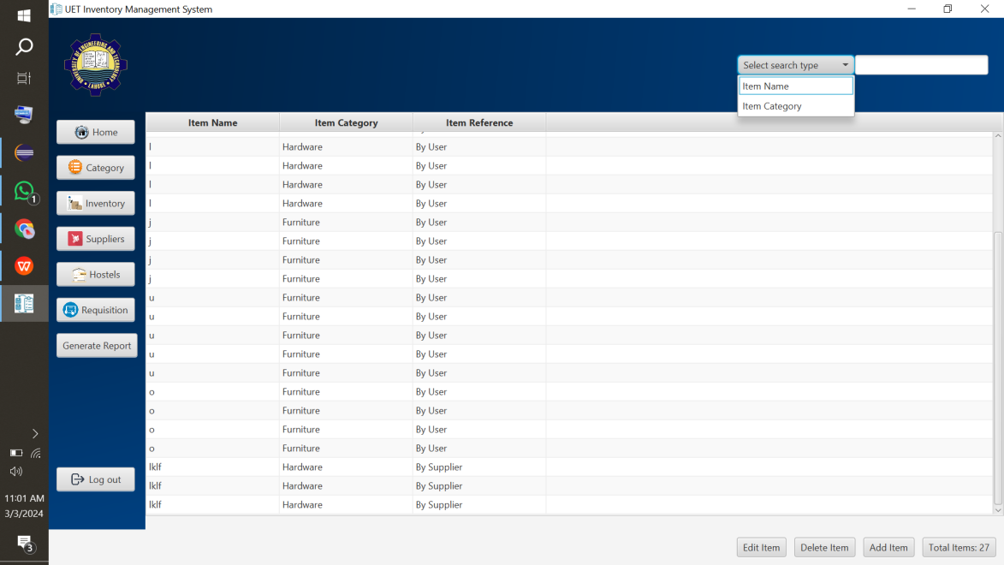

B6

B4

B7

B2

D1

D2

B11

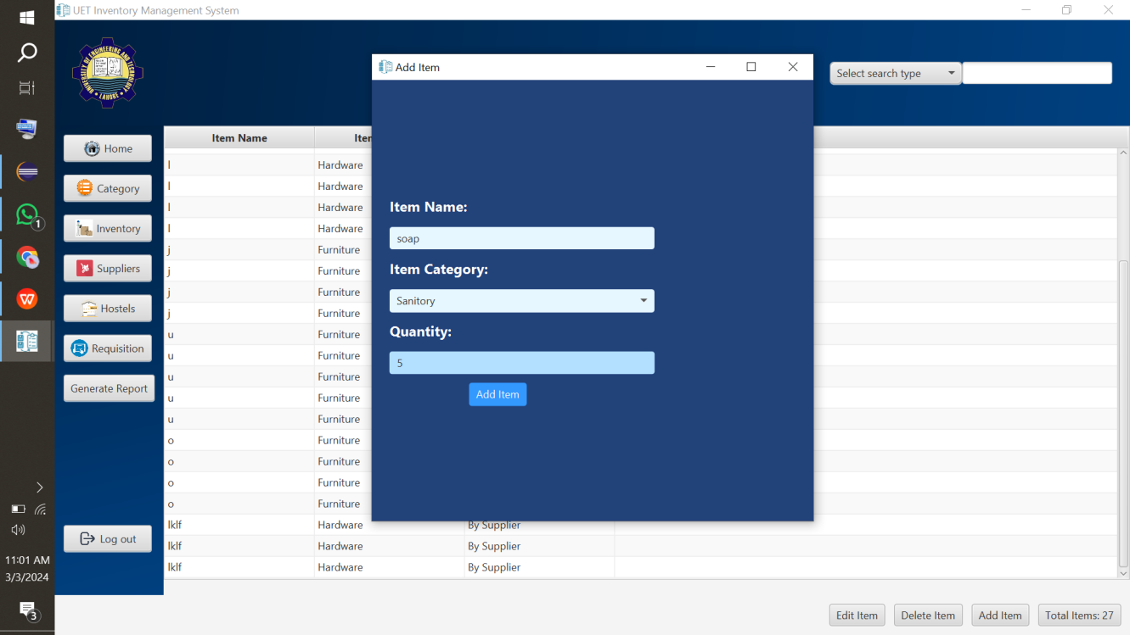 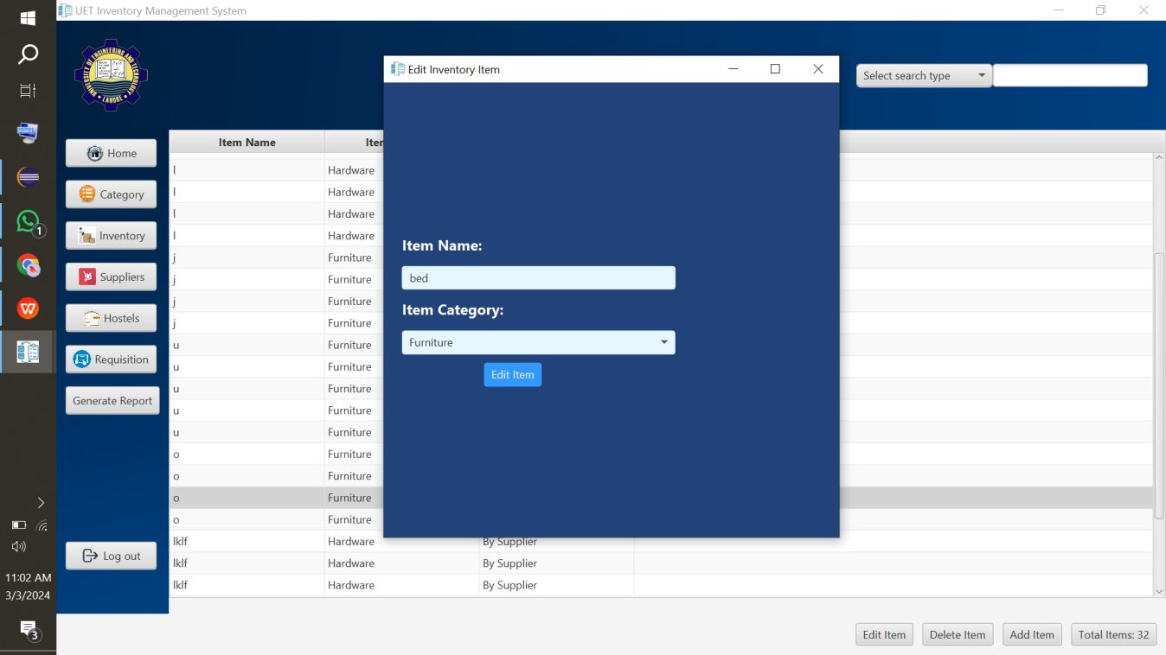

B3

B5

D4

D3

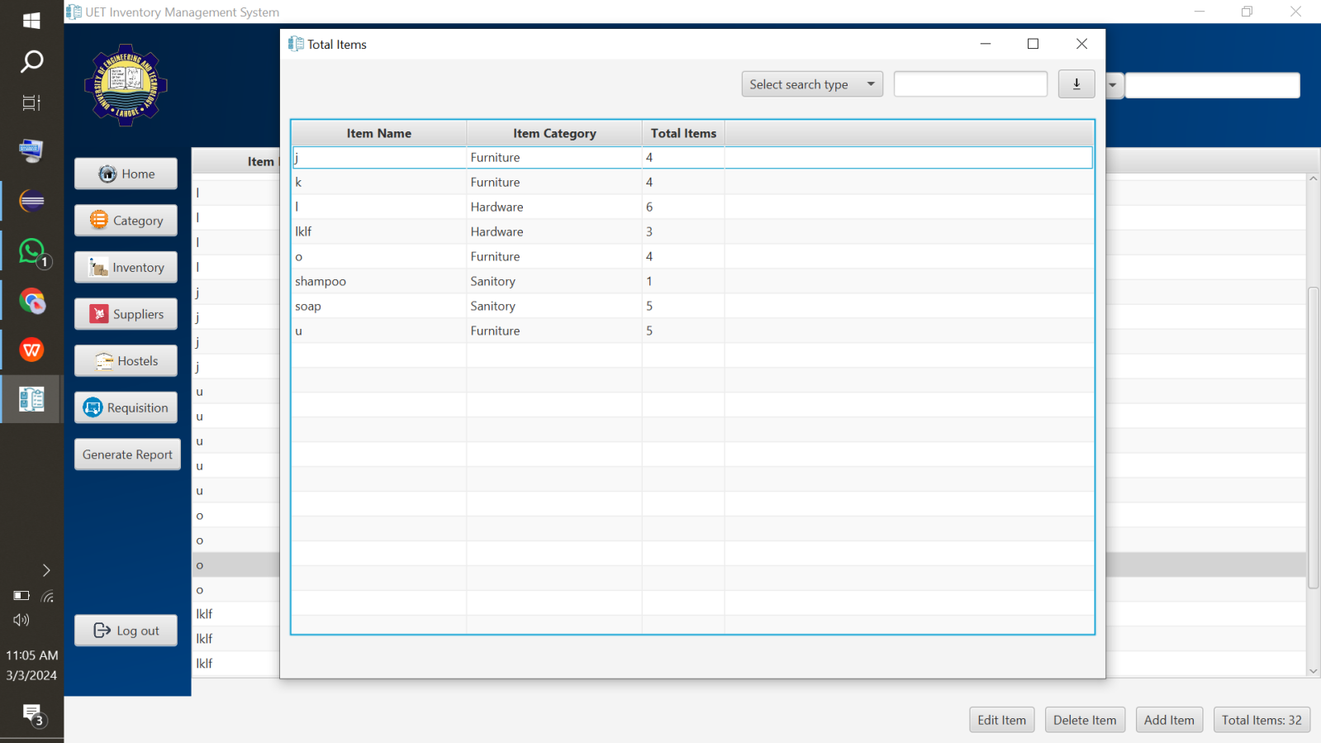

B8

**Note:** When you add item from this page, it is assumed that these items have already been in inventory and you are saving data here. Otherwise to add new items to inventory through suppliers, we would discuss later in Student Requisition Section.

**Note:**You can select multiple items at a time to edit or delete by **ctrl+click**(mousepad).

**Note:** You can edit or delete those items that you have added manually from this item page.

**Warning:** Editing or deleting item supplied by any supplier would be edited or deleted in supplier item page as well. E.g chair is supplied by supplier Ali so if editing it as table on inventory page, system would ask confirmation if you want to update this supplier item and if you confirm, it would update on inventory as well as supplier item page.

**Warning:** Make sure you are adding correct quantity of items otherwise you would have to search for particular item and click **ctrl+a** and delete or edit button to delete or edit all undesired quantity or manually select items you want to delete or edit by selecting them as **ctrl+click**(mousepad).

**Warning:** When selecting multiple entries and clicking edit button, previous text would not be shown but whatever you would write would be updated for all selected entries. E.g. you selected an item chair, 2 tables and clicked edit button and written iron as item name so chair and 2 tables would be renamed as iron.

**Warning:** Total count on Total Item Button does not immediately get updated on adding new inventory item but when you click on another page like hostel, supplier or any other and come back to inventory page, it would be updated but no. Of items in summary get immediately updated when clicking Total Item button.

**Supplier Button:**

* Click Supplier Button(B1).
* Click Add Supplier(B2) to add supplier.
* On clicking Add Button, a new page would be opened. Fill all data fields and click add supplier(B3).
* Search supplier by selecting Supplier Name from drop-down menu (D1) and then type desired data in search-placeholder(D2).
* Select a supplier and click Edit Button(B4) that new page would be opened, edit desired field and click edit supplier button(B5) to edit it.
* Select a supplier and click Delete Button(B6) to delete it.
* Select a supplier and click View Items Button(B7) to view items supplied by respective supplier.
* Click Item Summary Button(B8) to view overall item count supplied by suppliers.
* On clicking Item Summary Button(B8) , a new page would be opened. You can view and download item summary by clicking download icon(B9). Search by selecting Item Name, or Item Category from drop-down menu(D3) and then type desired data in search-placeholder(D4).

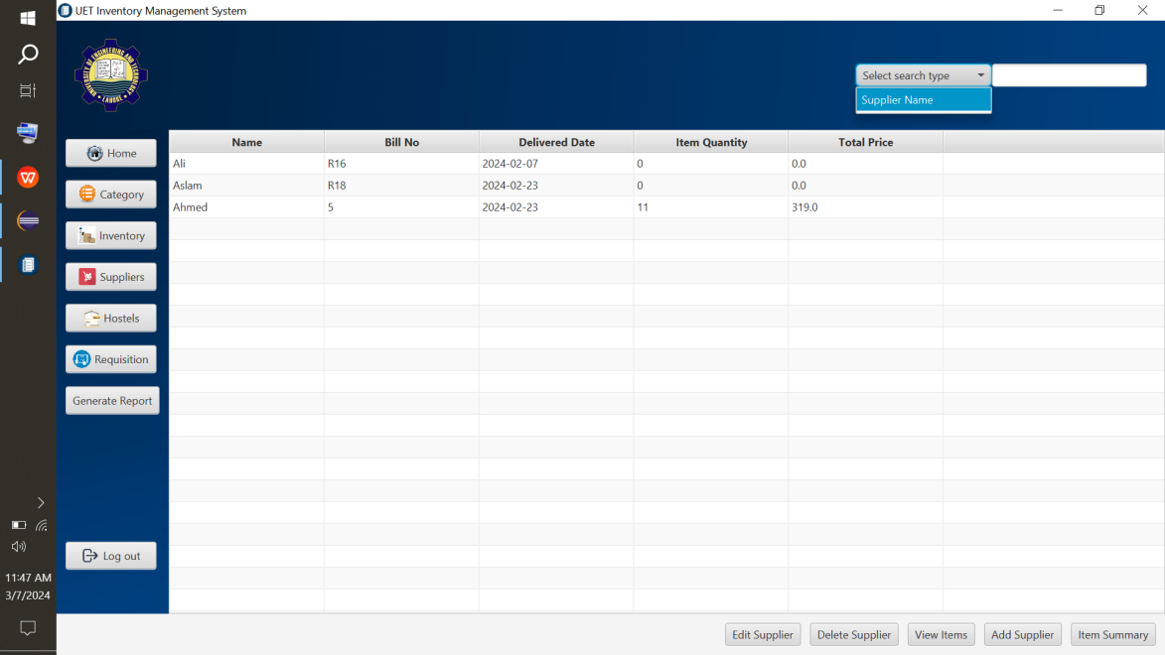

D1

D2

B11

B8

B2

B7

B6

B4

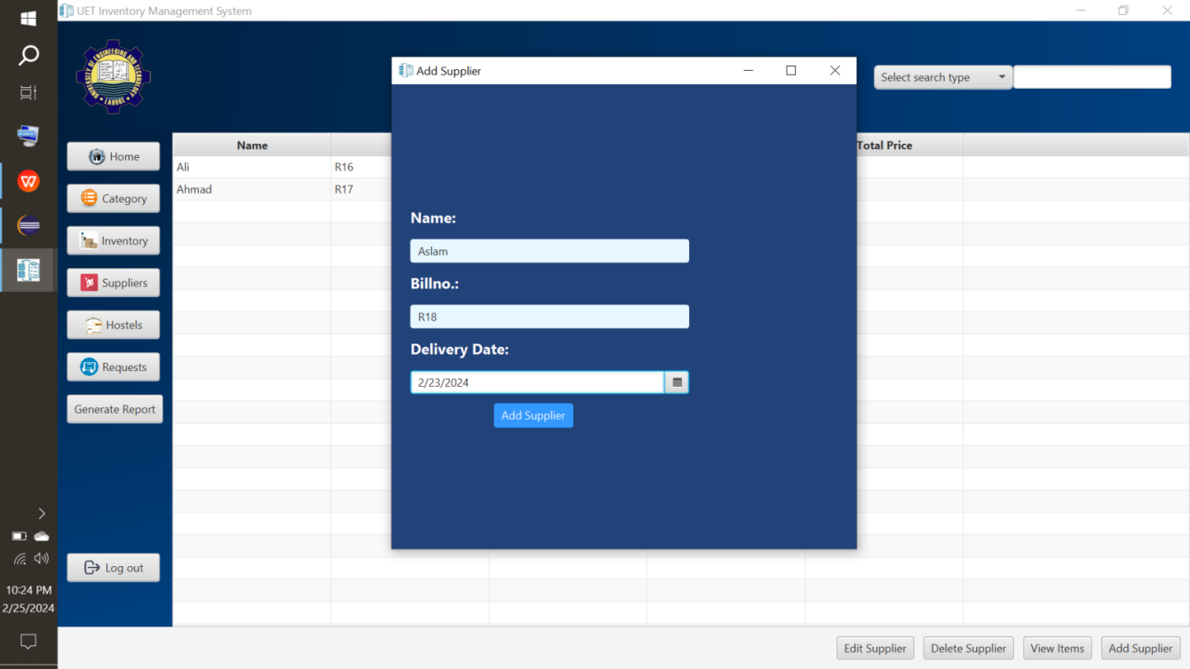 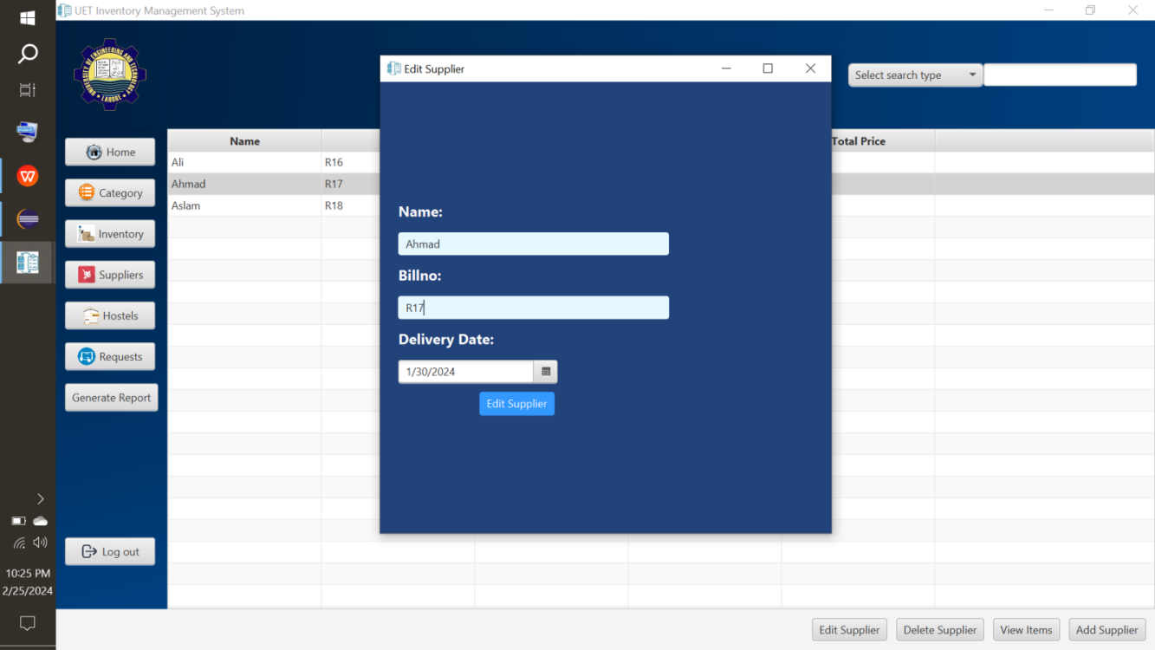

B3

B5

D4

D3

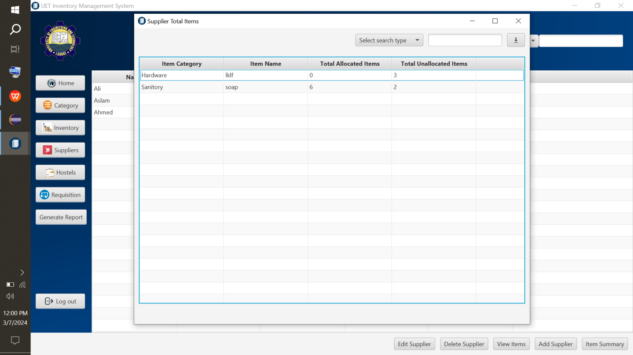

B9

**Warning:** Deleting supplier will delete respective supplied items as well.

**Warning:** You can’t delete the supplier whose items have been allocated.

**View Item Button(Supplier Item):**

* Select a supplier to view items of respective supplier from supplier page( the screenshot given in **Supplier Button**) and click **View Item Button**(B1).
* Click Add Item(B2) to add item.
* On clicking Add Button, a new page would be opened. Fill all data fields and click add item(B3). This item would automatically be added to inventory. You can view it in inventory page as well.
* Search item by selecting Supplier Item Name, or Supplier Item Category from drop-down menu(D1) and then type desired data in search-placeholder(D2).
* Select an item and click Edit Button(B4) that new page would be opened, edit desired field and click edit item button(B5) to edit it. Editing supplier item would update it in inventory as well.
* Select an item and click Delete Button(B6) to delete it.
* In this supplied item page, both allocated(to any room) and un-allocated(present in inventory) are displayed.
* Click View Supplier(B8) to go back to room page.

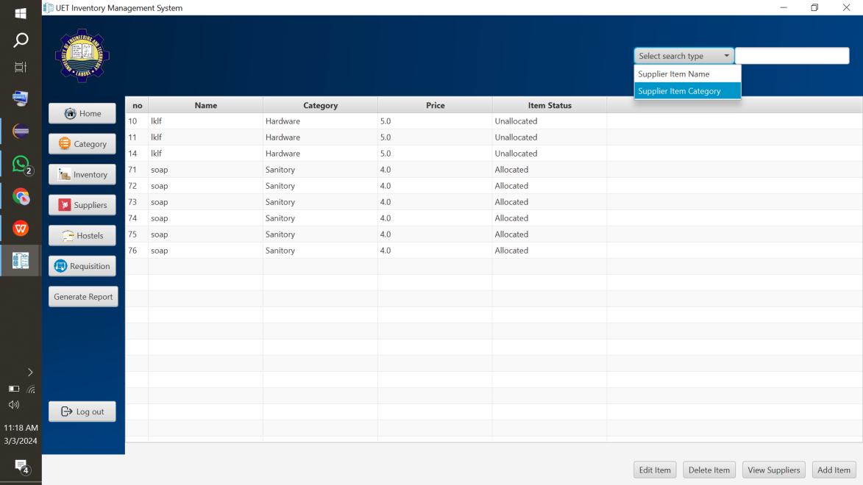

B2

B8

B6

B4

D1

D2

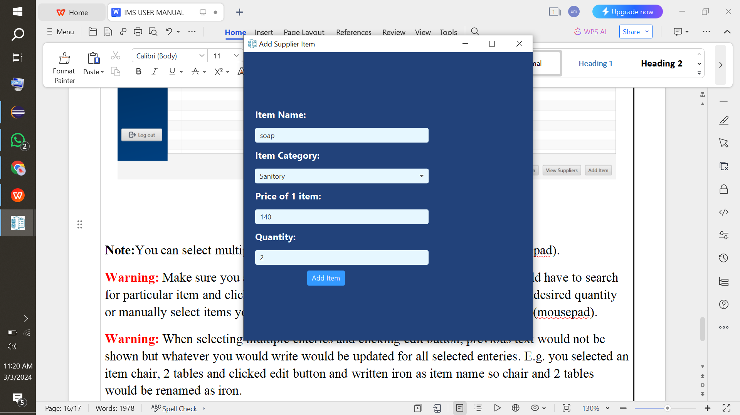 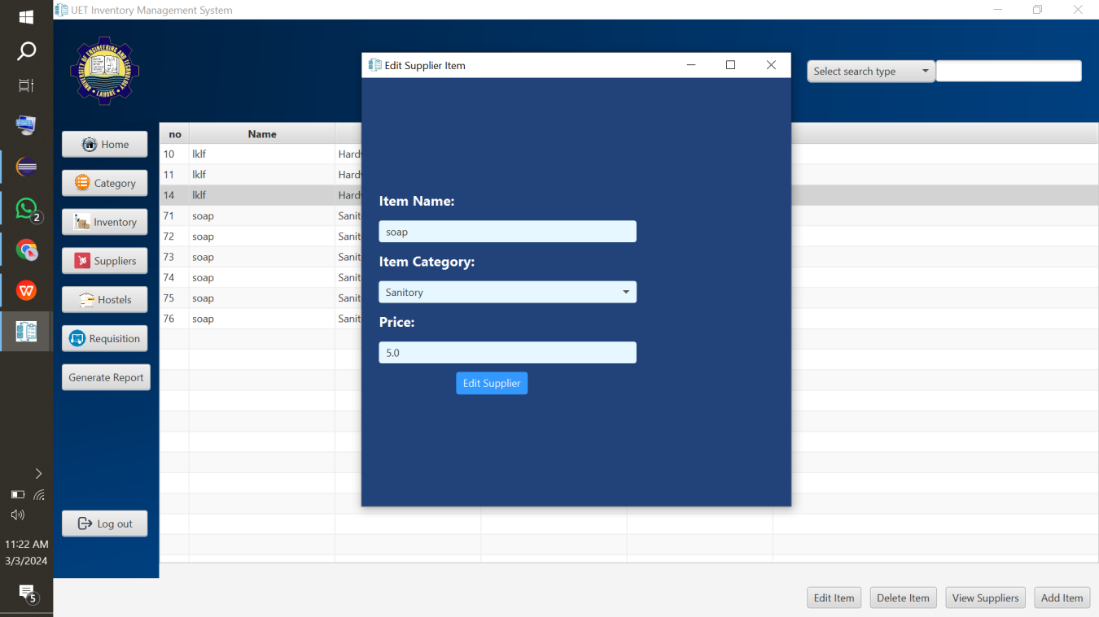

B5

B3

**Note:**You can select multiple items at a time to edit or delete by **ctrl+click**(mousepad).

**Warning:** Make sure you are adding correct quantity of items otherwise you would have to search for particular item and click **ctrl+a** and delete or edit button to delete or edit all undesired quantity or manually select items you want to delete or edit by selecting them as **ctrl+click**(mousepad).

**Warning:** When selecting multiple enteries and clicking edit button, previous text would not be shown but whatever you would write would be updated for all selected enteries. E.g. you selected an item chair, 2 tables and clicked edit button and written iron as item name so chair and 2 tables would be renamed as iron.

**Warning:** Editing or deleting item supplied by any supplier would be edited or deleted in inventory item page as well. E.g chair is supplied by supplier Ali so if editing it as table on supplier item page, system would update on supplier item page as well as on inventory page.

**Warning:** You can not edit or delete supplier items that does not exist that means they have been allocated to room.

**Requisition Button:**

* Click Requisition Button (B1).
* Click Add Button(B2) to add requisition.
* On clicking Add Button, a new page would be opened. Fill all data fields and click add requisition button (B3).
* Select a requisition and click Edit Button(B4) that new page would be opened, edit desired field and click edit requisition button(B5) to edit it.
* Select a requisition and click Delete Button(B6) to delete it.
* Search requisition by selecting Hostel, Room no., Items, Category, or Status from drop-down menu(D1) and then type desired data in search-placeholder(D2).

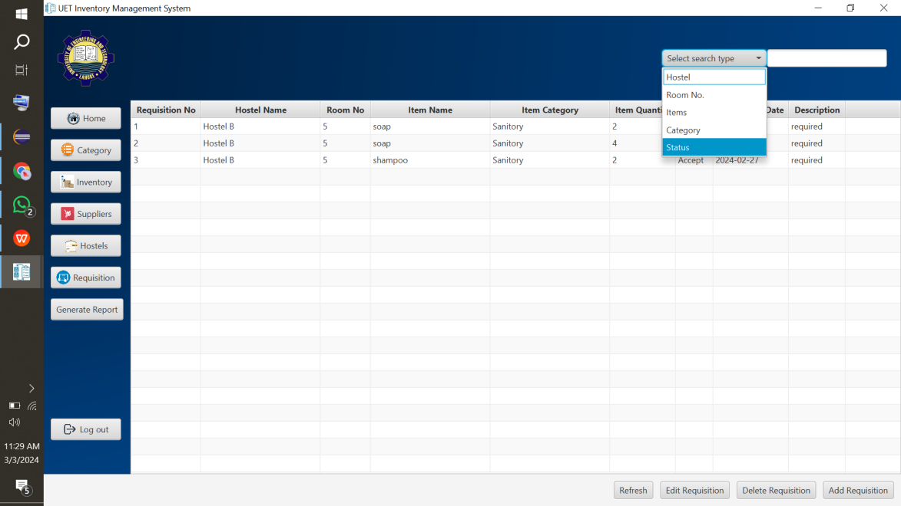

B4

B2

B6

D1

D2

B11

**Add Requisition Button:**

1. **Reject Status**

* On clicking Add Button, a new page would be opened. Fill all data fields, select reject as status and click add requisition button (B3) for requests that are to be rejected.

1. **Accept Status**

* On clicking Add Button, a new page would be opened. Fill all data fields, select accept as status and click add requisition button (B3) for requests that are to be accepted. If the desired item in desired quantity is present in inventory, then only request be added (see 1st picture) else if desired quantity is greater than quantity present in inventory, it would tell the quantity of desired item present in inventory and would not add request(see 2nd picture).

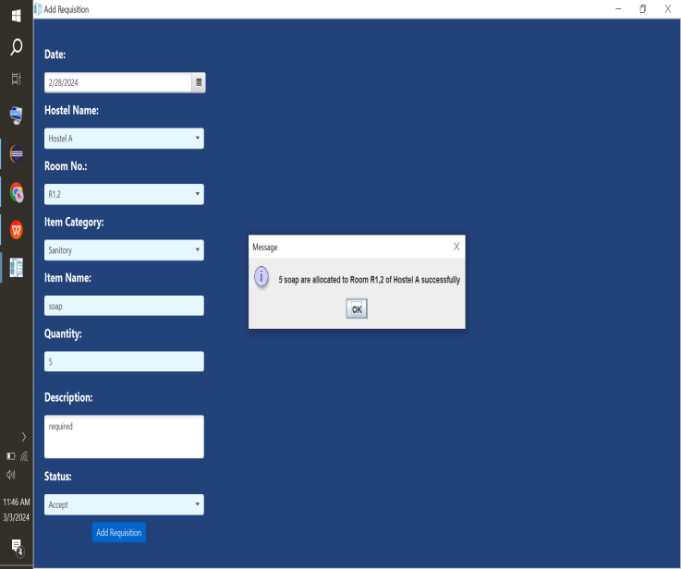 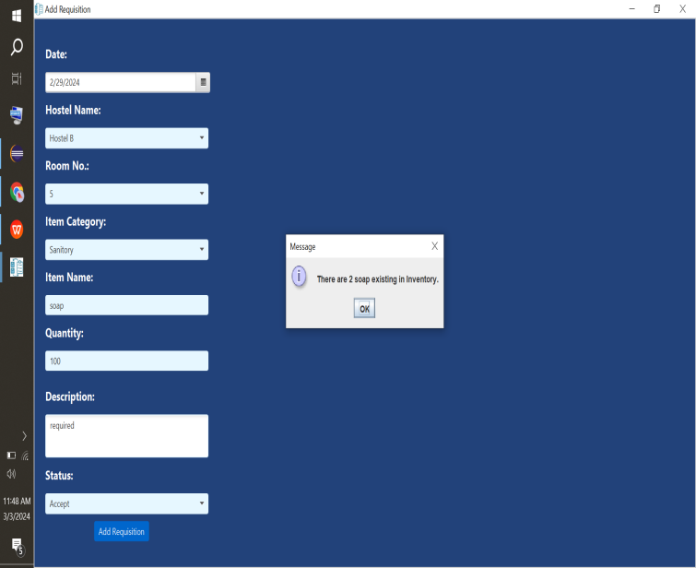

B3

B3

1. **In-progress Status:**

* On clicking Add Button, a new page would be opened. Fill all data fields, select in-progress as status and click add requisition button (B3) for requests that are to be later accepted. If the desired item in desired quantity is present in inventory, then upon clicking refresh button(B4) would show status as in-progress(check inventory)(R1) so if you may accept later.

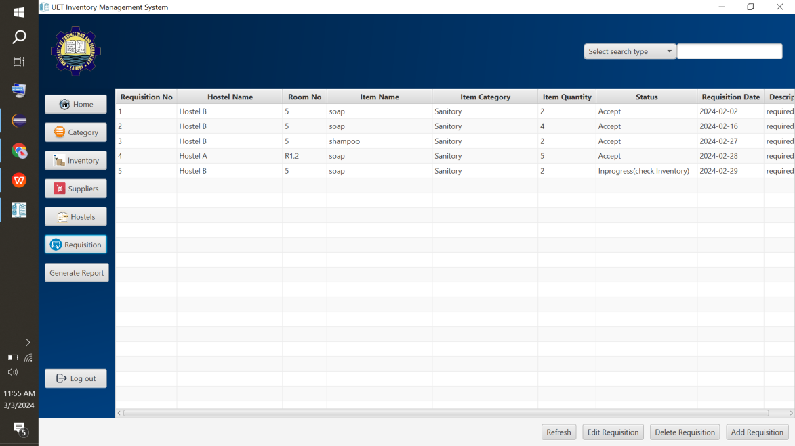

R1

B4

B3

**Edit Requisition Button:**

1. **Reject Status**
2. **Previous Reject and Edited as Reject**

* On clicking Edit Button, a new page would be opened. If status was as reject before and now as well, you can edit any field and click edit requisition button (B3) for requests that are to be rejected.

1. **Previous In-progress and Edited as Reject**

* On clicking Edit Button, a new page would be opened. If status was as in-progress before and now as reject, you can edit any field and click edit requisition button (B3) for requests that are to be rejected.

1. **Previous Accept and Edited as Reject**

On clicking Edit Button, a new page would be opened. To de-allocate items from room and store them again in inventory, you can edit accepted status as reject. In this case, only date, status and description are editable while others are un-editable.

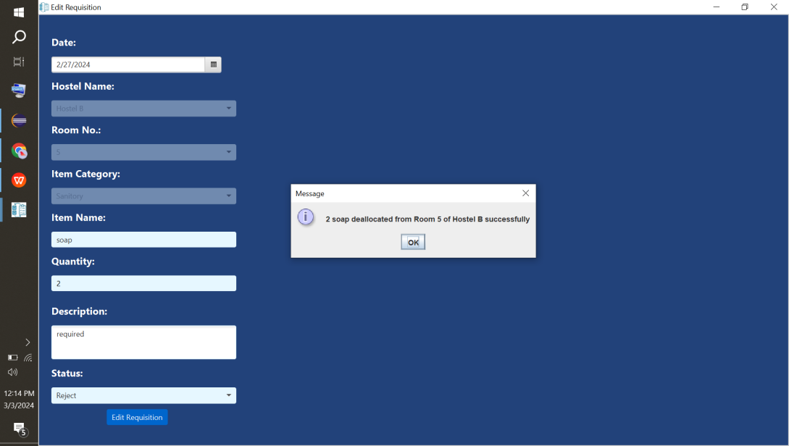

B3

1. **In-Progress Status**
2. **Previous Reject and Edited as In-Progress**

* On clicking Edit Button, a new page would be opened. If status was as reject before and now as in-progress, you can edit any field and click edit requisition button (B3) for requests.If the desired item in desired quantity is present in inventory, then upon clicking refresh button(B4) would show status as in-progress(check inventory)(R1) so if you may accept later.

1. **Previous In-progress and Edited as In-Progress**

* On clicking Edit Button, a new page would be opened. If status was as in-progress before and now as in-progress, you can edit any field and click edit requisition button (B3) for requests.If the desired item in desired quantity is present in inventory, then upon clicking refresh button(B4) would show status as in-progress(check inventory)(R1) so if you may accept later.

1. **Previous Accept and Edited as In-Progress**

On clicking Edit Button, a new page would be opened. To de-allocate items from room and store them again in inventory, you can edit accepted status as in-progress or reject. In this case, only date, status and description are editable while others are un-editable.

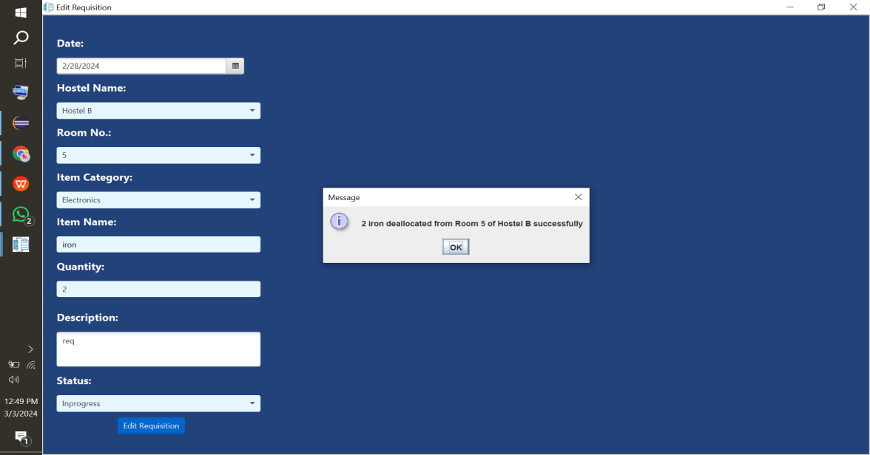

B3

1. **Accept Status**
2. **Previous Reject and Edited as Accept**

* On clicking Edit Button, a new page would be opened. If status was as reject before and now as accept. If the desired item in desired quantity is present in inventory, then only request be edited else if desired quantity is greater than quantity present in inventory, it would tell the quantity of desired item present in inventory and would not edit request.

1. **Previous In-progress and Edited as Accept**

* On clicking Edit Button, a new page would be opened. If status was as in-progress before and now as accept. If the desired item in desired quantity is present in inventory, then only request be edited else if desired quantity is greater than quantity present in inventory, it would tell the quantity of desired item present in inventory and would not edit request.

1. **Previous Accept and Edited as Accept**

On clicking Edit Button, a new page would be opened. If status was as accept before and now as accept. If the desired item in desired quantity is present in inventory, then only request be edited else if desired quantity is greater than quantity present in inventory, it would tell the quantity of desired item present in inventory and would not edit request.

**Delete Requisition Button:**

* You can not delete accepted requests.

**Generate Report Button:**

* Click Generate Report Button(B1).
* On clicking Generate Report Button(B1), a new page would be opened. Fill month and year of which you want to view supplier report and click Generate Report(B2).
* On clicking Generate Report Button(B2), a new page would be opened displaying supplier report of respective month and year.
* Select supplier(S1) to see respective supplied category and items of respective supplier.
* After selecting supplier, select category(C1) to see respective supplied items of respective category of respective supplier.
* You can download report by click download icon(B3).

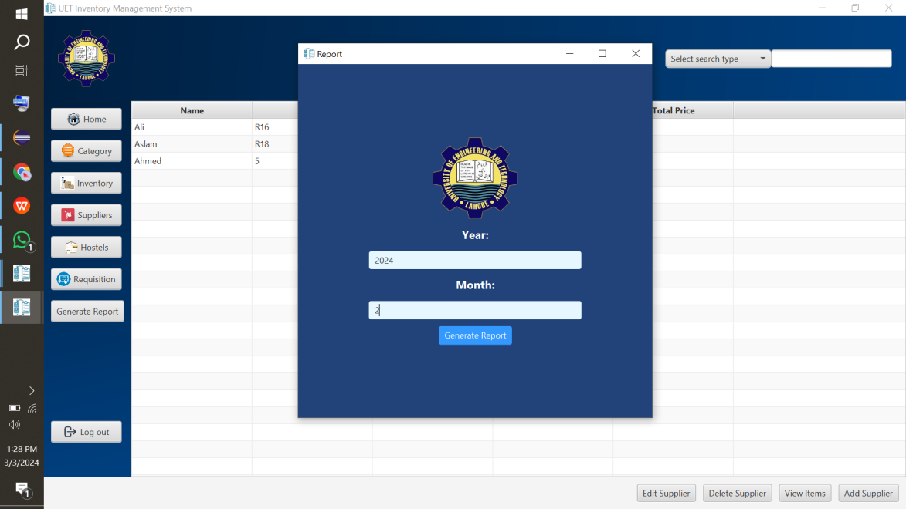

B2

B1

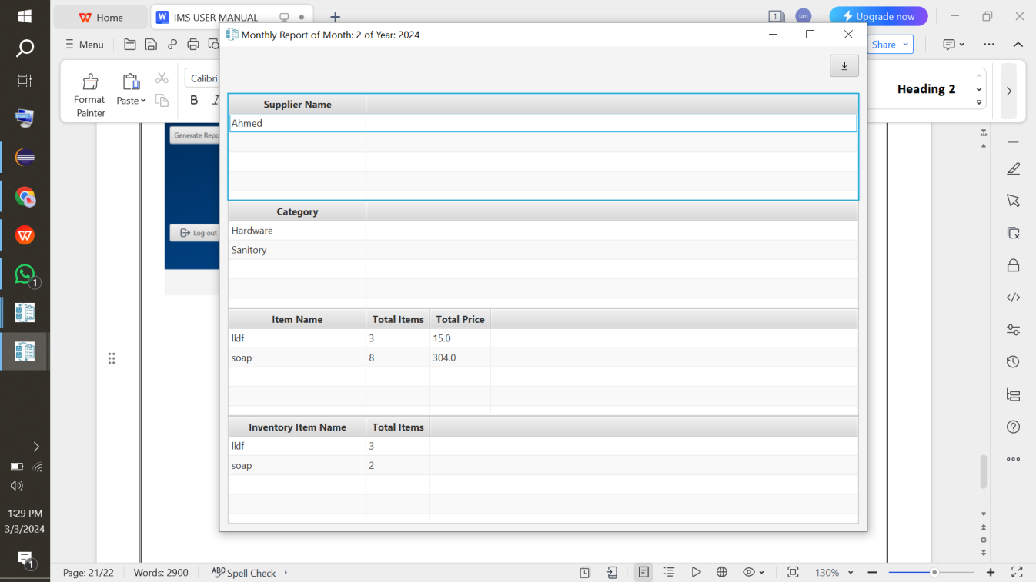

C1

S1

B3

**Contact Us:**

**Email:** ukkildevelopers@gmail.com